1. For the first flash, you need to install DFU driver: open DFU_DriverInstall and install DFU_DriverInstall.exe

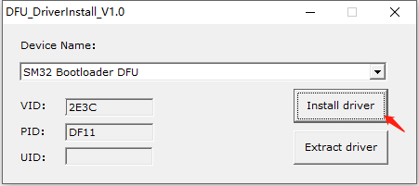

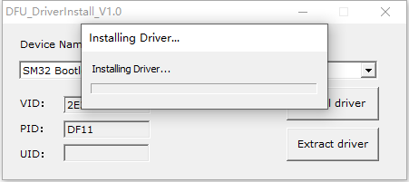

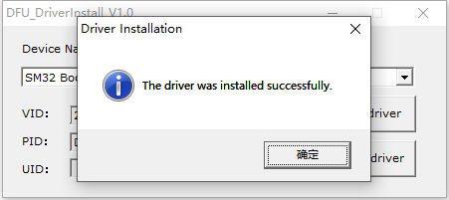

1. Open WuqueDFUupgradeProgrammer

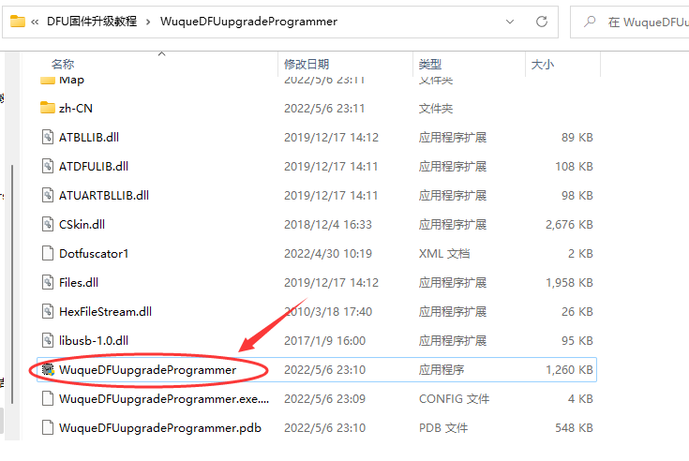

1. When you checked automatically switch to DFU mode, no need any operation, the keyboard will automatically enter the Bootloader mode, then select the firmware and click manually download to flash

**Note:**

1. If you checked automatically into DFU mode, the keyboard will automatically enter DFU again after firmware flash finished. At this time just need to close the upgrade software or unchecked automatically switch to DFU mode, then insert the USB again, keyboard can be used normally

2. In firmware flash processing, do not disconnect the USB, otherwise there is a risk of dead

3.You need to close the driver software first, the upgrade software to recognize the

device.

